Part I: Which goes with which?

You will receive a handful of several different kinds of rice. Your job is to sort them.

- How can you tell the difference between these grains of rice? Which characteristics would you use to divide these rice grains into groups.
  - _____________________________
  - _____________________________
  - _____________________________

- Sort your rice into groups.

- Organize your groups on a blank sheet of paper. Put the groups that are most similar closest together. Put the groups that are most different farthest apart.

- Draw an outline around each group. Number the group. Trace three grains of rice inside the group.
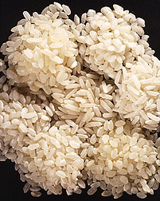
USDA-ARS
Part II: Phenotype

- Pick the two piles that are most different from one another. Describe the PHYSICAL APPEARANCE of each group. (What color is it? How long are the grains? How does it feel? How does it smell?)

Group Number _________ Group Number _________
  - ____________________________ a. ____________________________
  - ____________________________ b. ____________________________
  - ____________________________ c. ____________________________

What you’ve just described is the PHENOTYPE. A phenotype is the physical description of something… in this case, a grain of rice.

- Do all the grains of rice in Group 1 have the same phenotype? Why or why not?

- Does the rice in Group 1 have the same phenotype as the rice in Group 2? Why or why not?

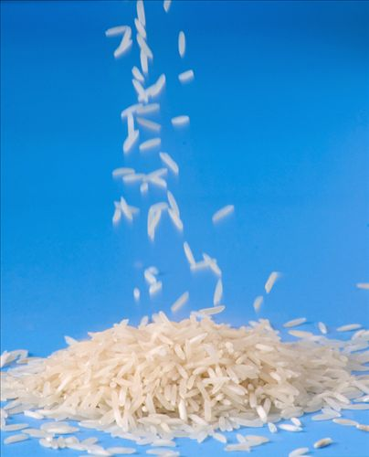
Part III: Genotype

- What is a gene?

- Does a grain of rice have genes? Why or why not?
USDA-ARS

- How are genes related to phenotype?

A GENOTYPE is the genes that an individual has (whether that individual is a rice plant, a lizard, or a human being).

- Do all the grains of rice in Group 1 have the same genotype? Why or why not?

- Does the rice in Group 1 have the same genotype as the rice in Group 2? Why or why not?

__________________________________________________________________

Part IV: Applying what you’ve learned

- Someone tells you that a rice plant has purple grain. Is this a genotype or a phenotype?

- Someone tells you that a rice plant has a gene for a puple pigment called anthocyanin. Is this a genotype or a phenotype?

Part VI: Comparing varieties

 | Color | Length | Taste of cooked rice | Texture of cooked rice | Country of origin? | Fact
1) Himalayan red rice | Red husk, white grain | Long grain | Nutty flavor | Dry and fluffy | India | It is the most expensive of all rice varieties.

2) Brown basmati rice

3) Bamboo rice

4) Sweet brown rice

5) Thai purple rice

6) Basmati rice

7) Calrose rice

8) Arborio rice

9) Chinese black rice

