Activity 1. What do rice plants need to grow?
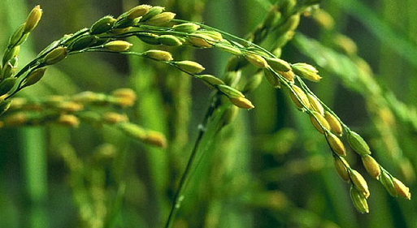

Objective
Design and conduct an experiment to determine what rice plants need in order to grow.

Background
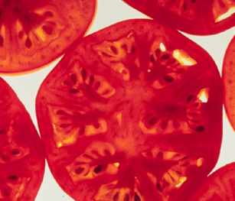
Plants are an essential part of our lives. They provide us with food, shelter, fuel, and clothing. And yet, we often don’t pay much attention to them. What do plants need to grow?

Materials
- Rice seeds
- Containers
- Soil
- Water source and watering method
- Other resources to be determined

__________________________________________________________________

Part I: Brainstorming

- What things do plants need in order to grow?

- You and your group will design an experiment to investigate one of these “needs”. Which “need” will your group be investigating?

__________________________________________________________________

Part II: Experimental Design
- A variable is something that you change in an experiment. What is your variable?

- In order to understand the effects of your variable, all the other conditions should be exactly the same. These conditions are held constant. Why is it important to have conditions held constant?

- Fill in the table to show which conditions you are going to hold constant and which you are going to vary. For the constants show what you will do.
Characteristic | Example Experiment |  | Your Experiment
Characteristic | Constant or variable? | What will you do? | Constant or variable? | What will you do?
Light | constant | windowsill
Water | constant | keep soil damp
Salt | constant | no salt
Fertilizer | constant | 3 pieces per pot
Soil | VARIABLE | VARIABLE
Temperature | constant | room temperature
other

- Your hypothesis.
A hypothesis is a possible explanation or an educated guess about what you will find. It is a starting point for your experiment.

How do you think your variable will affect rice plants?
Example hypothesis:
I expect that __soil __ will cause the plants to _grow__ because they need a place to put their roots_.
Too much __soil __ will lead the plants to _not grow because they won’t be able to get out of the soil to the light_.
Not enough __soil __ will lead the plants to not grow because they won’t have a place to put their roots or a way to take in water.

Your hypothesis:
I expect that _________________ will cause the plants to ______________________________ because_______________________________________________________________________.
Too much ______________will lead the plants to _____________________________________ because_______________________________________________________________________.
Not enough ______________will lead the plants to ____________________________________ because_______________________________________________________________________.

- Controls and treatments.
To see the effect of your variable, you must compare it against a control.

5a. For your variable, what do you think is the “best practice” for your variable? This will be your control.
Example control:
Rice plants will grow best when soil is _____present and not packed down____.

Your control:
Rice plants will grow best when _________ is _______________________________.

5b. What are your treatments?
Example treatments:
To understand the importance of ____ soil ____ , I will compare my control to
1) _____seeds in a pot with no soil______________________________________________, and
2) ____ seeds in a pot with twice as much soil as my control, packed down__________________.

Your treatments:
To understand the importance of _____ , I will compare my control to
1) ________________________________________________________________________, and
2) ____ ________________________________________________________________________.

- What supplies will you need? How will you get any that are not already available in the classroom?

- How will you measure your results?

- What will you need to do every day?

Part III: Data and results

- Use this space to record your data:
Plant | Control: | Treatment 1: | Treatment 2:
1.
2.
3.
4.
Total
Average

- Graph your data.

_________________________________________________________________________

Part IV: Your Conclusions

- What does this experiment tell you about the importance of your variable? (What did you learn from your experiment?)

- Did you have any unexpected results? What were they and why do you think they happened?

- How could you improve your experiment? (Are there ways your experiment could be improved to better answer the initial question? Did you come up with questions you can’t answer using your data?)

Part V: What do rice plants need in order to grow? (Learning from each other)
Each group will give a 3 minute presentation describing 1) what their experiment told them what rice plants need to grow and 2) making a recommendation of the “best practice” for their variable. You will need to answer the questions below (by taking notes!)

- What does this experiment tell you about the importance of each variable for rice plants?
Variable | Importance | “Best Practice”
Light
Water
Salt
Fertilizer
Soil (Example) | Plants need soil for their roots. When rice plants have no soil, they die. When the soil is dense, rice plants grow more slowly. | Use soil. Don’t compact it.
Temperature

