West African Environments Activity

There are four major rice farming environments in West Africa—each shapes the rice farming practices and humans, in turn, have shaped the environment to be able to grow rice:
Rice growing zones in central Gambia. From Black Rice by Judith Carney
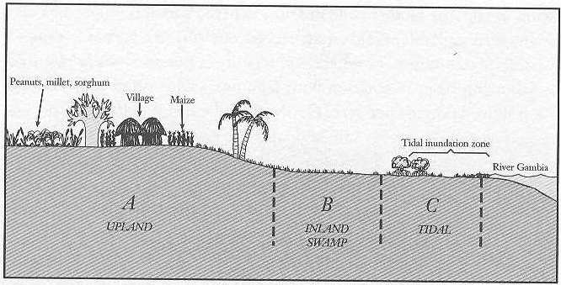

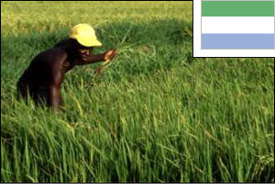
- Rain-fed uplands—In these environments, rice cultivation depends completely on rainfall. Planting happens between April and June, when the rains arrive. Typically, forest is cleared for planting—a job that takes lots of labor. Rice seed is planted directly into the well-drained soils. Short-season varieties of rice are grown because rains only last 3-4 months. After planting, farmers weed their fields, but do not use fertilizers or pesticides because they usually cannot afford them. They also do not manage the water with canals and gates. Instead they rely on rainfall. These lands, found in Sierra Leone and Libera, receive more than 35 inches of rain per year.
A man weeding rice in Sierra Leone. http://www.fao.org/rice2004/en/p18.htm

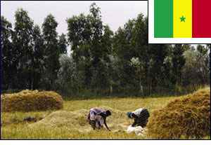
- River floodplains—Along the Senegal, Niger and Gambia rivers, rice is often grown in the river waters. Each season, when the rains arrive in June or July, the river waters rise and spill out of river bed, washing over the fields and depositing rich soil to nourish rice. Farmers prepare their fields early. When the floodwaters come, they transplant rice seedlings into the wet soil. After that, they let the river feed and water their plants. In some places where the river does not flood, farmers build irrigation canals to carry water from the river to their fields.
Women harvesting rice in Senegal. http://www.fao.org/rice2004/en/p11.htm

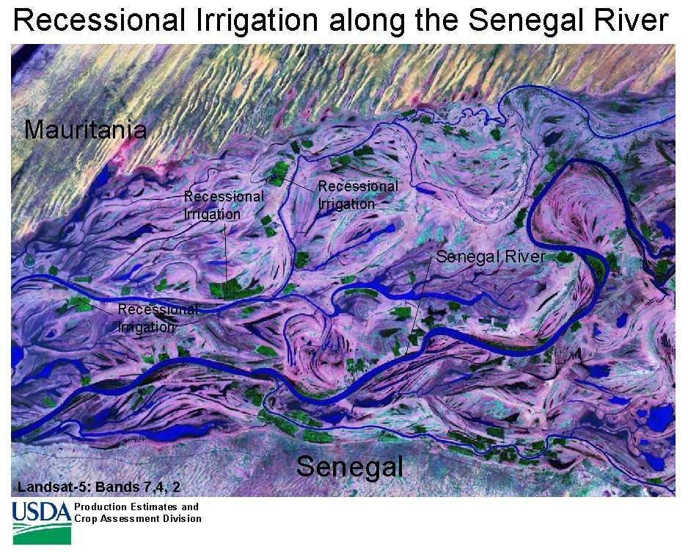
Green patches are rice growing in the tidal floodplain of the Senegal River. http://www.fas.usda.gov/pecad2/highlights/2001/10/senegal/pictures/recessional_irrigation.jpg
- Tidal floodplains—Where the rivers meet the oceans, West African farmers practice an unusual form of rice growing. These farmers wait for the wet season to end and the river floodwaters to recede in late fall or early winter. Then they transplant small rice plants into the wet ground. They rely on moisture retained in the soil to keep the plants growing through the dry season. The land is harvested at the height of the dry season in April or May.

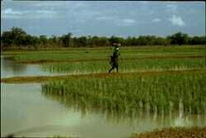
- Mangroves—At the mouth of the Niger and several other rivers, West African farmers have developed an amazing system for growing rice. In these coastal mangrove estuaries, when the tide “goes out” fresh water flows from the river into the ocean. When the tide “comes in” salt water flows from the ocean into the river. Salt water will kill rice plants. Therefore farmers have built big dirt walls to keep salt out. They rely on the same walls to catch and hold rainwater. The soil is heavy clay and therefore holds the water. The mangrove systems are, amazingly, the most agriculturally productive but require sophisticated water management. Canals, dikes, walls and sluice gates keep the salt water out while retaining the fresh water.
Woman walking between mangrove rice fields. http://www.cirad.fr/en/actualite/communique.php?annee=2005&id=268

Objective
Modify environment to make it hospitable for growing rice.

Materials
- Rice seed
- Containers
- Soil
- Trowels and other dirt-moving equipment
- Straws (to use for sluices)
- Soap and water for cleanup

__________________________________________________________________

Activity

Part I: Your Environment

- Describe the environment your group will work on.
1a. What kind of soils does it have?
Rain-fed uplands: loose, well-drained; River floodplains: rich, well-drained; Tidal floodplains: heavy clay, poorly drained; Mangroves: heavy clay, poorly drained.
1b. Does the water drain through your soils or is it held by them?
Rain-fed uplands: well-drained; River floodplains: well-drained; Tidal floodplains: poorly drained; Mangroves: poorly drained.
1c. Where does the water come from to grow rice?
Rain-fed uplands: rainfall; River floodplains: the river (indirectly rainfall); Tidal floodplains: residual moisture left from the flooded river; Mangroves: rainfall.
1d. Does your environment have any special structures you will need to build?
Rain-fed uplands: none; River floodplains: none OR irrigation canals (maybe a mound around the perimeter of the field); Tidal floodplains: probably a mound around the perimeter of the field; Mangroves: large mounds around perimeter of the field, possibly canals, dikes, walls and sluice gates..
1e. Does your environment have any special problems you’ll need to deal with?
Rain-fed uplands: none (timing of the rainfall); River floodplains: none (timing of the river flood); Tidal floodplains: timing of receding floodwaters versus drying of the soil; Mangroves: keeping salt water out, getting enough water.

- Using the materials provided, create a version of your environment.

________________________________________________________________________

Part II: Growing rice

Your goal is to grow rice in your environment.

- What does rice need to grow?

If students have done the “What does rice need to grow?” Activity, they can draw upon that information.
If not, from their own experience, they can probably come up with light, water, fertilizer, soil, temperature. Plants also need an environment free of salt..

- Does your environment need to change in order to grow rice? (Be sure you think about the soil, nutrients and water-management?)

The answer will vary by environment.
For example, in the rainfed uplands, the forest must be cleared, but after that is done, the soil is good and the water is plentiful.
In the mangroves, salt is the biggest problem. Rainfall, if captured, can wash away the salt. Walls are built to keep salt water out.

- Plant rice in your environment. (Modify it if necessary to make it ready for growing rice.)
Students will plant a few seeds, simply to see if they can grow rice in their modified environment.

_________________________________________________________________________

Part III: Conclusions
Each group will make a 5 minute presentation about 1) their environment, 2) the modifications they made in order to grow rice and 3) the modifications that are ACTUALLY made in West Africa.

Take notes in order to fill in the following table.
Group | Environment description | Modifications to grow rice

1. Where does the water come from to grow rice?
Rain-fed uplands: rainfall; River floodplains: the river (indirectly rainfall); Tidal floodplains: residual moisture left from the flooded river; Mangroves: rainfall.

2. Which environments have special problems that require special structures?
Rain-fed uplands: none (timing of the rainfall); River floodplains: none (timing of the river flood); Tidal floodplains: timing of receding floodwaters versus drying of the soil; Mangroves: keeping salt water out, getting enough water requires the creation and maintenance of large mounds around perimeter of the field, possibly canals, dikes, walls and sluice gates.

3. What does rice need to grow?
Light, water, nutrients, soil, warm temperature, and an environment free of salt.

Teacher Notes. West African Environments

Overview and concepts

Overview
Students experiment with how to make rice grow in each of these environment types: rainfed uplands, river floodplains, tidal floodplains and mangroves. Students will have to modify their environment (build canals, dikes, walls, sluices) to control water. (I forsee a lot of dirty hands in this project!). The take-home message is about how the biome (climate, soil, rainfall, vegetation) shapes agriculture.

Concepts covered
Biomes, agriculture, landscape modification, soil structure, water movement.

Prior knowledge required
Students should have familiarity with the following:
- Biome: a major ecological community type (as tropical rain forest, grassland, or desert).
- West African cultures: Students will be covering this in social studies in the paired curriculum.

Activity notes

Time frame
- Activity—creation of the rice-growing environment: One class period. (?)
- Rice growth period—students will have to maintain the environment (water it) for at least two weeks while the rice germinates and begins to grow.

Materials
- Rice seed that will germinate (note that food rice has been processed and the embryo removed, so it will not germinate.)
- Containers (clear plastic storage tub.)
    - To create “well drained soils”, students can nest one container (with holes in it) inside of another container (without holes).
    - To create “poorly drained soils”, students can use only one container (no holes). Be careful not to over water or you’ll have to wait for the dry-season for the excess water to disappear!
- Soil
    - Regular potting soil should be fine.
    - If you have access to clay from an art classroom, you could mix it in to create the “poorly drained” heavy clay soils of the mangroves and tidal floodplains.
- Trowels and other dirt-moving equipment
- Gloves?
- Straws (to use for sluices)
- Soap and water for cleanup

Preparation
- A few weeks before the activity, make sure that you have all the rice seed you need. Extra rice can be kept fresh for up to a year in a sealed container kept in a refrigerator.
- Also make sure you have the soil necessary.
- We advise trying the environmental modification once for yourself to see potential pitfalls!

Teaching Tips
- Note that the student pages are designed so that you can give them out one at a time. This is so students won’t be overwhelmed by all the questions at once!
- It is probably safest to do this activity outside. If you cannot, then spread a bunch of newspaper on the floor, because it is bound to make a mess!
- It may be best to have the students work with soil that has already been wetted before they put it into their “environment.” Some potting soils will repel water the first time they are wetted.
    - To do this, you can put the soil in a big bucket, pour water in and mix it.
- Have students work in groups no larger than 4.
- Make sure students have a plan for tending their “environment” while the rice is germinating.

Taking it further
- This activity could easily be expanded to start with a sheet about the biomes where each of these practices occurs. Students could start by creating the natural environment.
- Then, as a second step, students could learn about how West Africans modify their environments in order to grow rice. Then students could do the same.
- Finally, if we could get the right types of seed (not a small obstacle, but one we’re working on!) students could do a final activity where they compare the way three varieties of rice grow in each environment. There would be a story about adaptation to special circumstances: rising water, salt tolerance, drought tolerance.

- Additionally, there is also a second story to be told about the rice environments in South Carolina. (This will link tightly to the social studies curriculum.) How are the envionments similar to and different from the African environments? How were rice farming practices adapted to local conditions?
- Students with their new muddy agricultural skills, now encounter a similar, but novel environment in which they have to make their rice grow (the South Carolina environment?). Which practices are going to be useful? Which will have to be adapted? Which will be discarded?

Further reading
West African Rice: Judith Carney. 2001. Black Rice: The African Origins of Rice Cultivation in the Americas. Harvard University Press.

Rice in Sierra Leone: http://www.fao.org/rice2004/en/p18.htm

Rice in Senegal: http://www.fao.org/rice2004/en/p11.htm

