West African Environments Activity

There are four major rice farming environments in West Africa—each shapes the rice farming practices and humans, in turn, have shaped the environment to be able to grow rice:
Rice growing zones in central Gambia. From Black Rice by Judith Carney
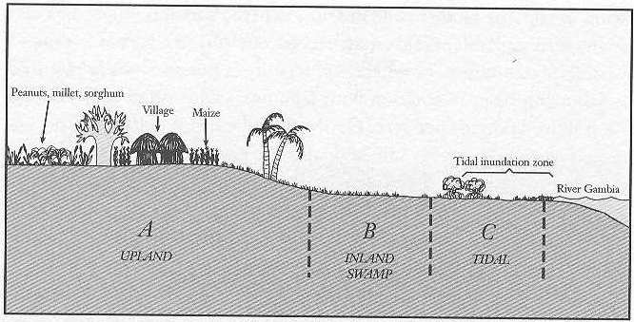

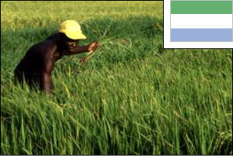
- Rain-fed uplands—In these environments, rice cultivation depends completely on rainfall. Planting happens between April and June, when the rains arrive. Typically, forest is cleared for planting—a job that takes lots of labor. Rice seed is planted directly into the well-drained soils. Short-season varieties of rice are grown because rains only last 3-4 months. After planting, farmers weed their fields, but do not use fertilizers or pesticides because they usually cannot afford them. They also do not manage the water with canals and gates. Instead they rely on rainfall. These lands, found in Sierra Leone and Libera, receive more than 35 inches of rain per year.
A man weeding rice in Sierra Leone. http://www.fao.org/rice2004/en/p18.htm

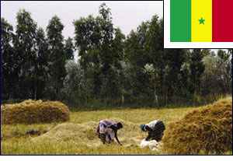
- River floodplains—Along the Senegal, Niger and Gambia rivers, rice is often grown in the river waters. Each season, when the rains arrive in June or July, the river waters rise and spill out of river bed, washing over the fields and depositing rich soil to nourish rice. Farmers prepare their fields early. When the floodwaters come, they transplant rice seedlings into the wet soil. After that, they let the river feed and water their plants. In some places where the river does not flood, farmers build irrigation canals to carry water from the river to their fields.
Women harvesting rice in Senegal. http://www.fao.org/rice2004/en/p11.htm

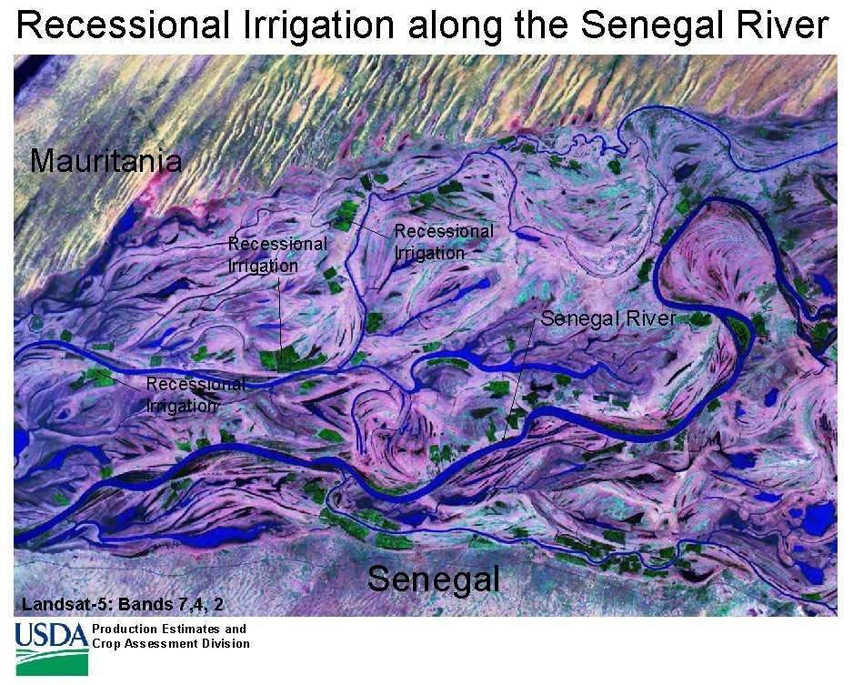
Green patches are rice growing in the tidal floodplain of the Senegal River. http://www.fas.usda.gov/pecad2/highlights/2001/10/senegal/pictures/recessional_irrigation.jpg
- Tidal floodplains—Where the rivers meet the oceans, West African farmers practice an unusual form of rice growing. These farmers wait for the wet season to end and the river floodwaters to recede in late fall or early winter. Then they transplant small rice plants into the wet ground. They rely on moisture retained in the soil to keep the plants growing through the dry season. The land is harvested at the height of the dry season in April or May.

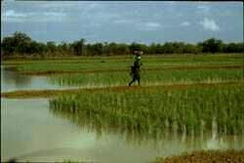
- Mangroves—At the mouth of the Niger and several other rivers, West African farmers have developed an amazing system for growing rice. In these coastal mangrove estuaries, when the tide “goes out” fresh water flows from the river into the ocean. When the tide “comes in” salt water flows from the ocean into the river. Salt water will kill rice plants. Therefore farmers have built big dirt walls to keep salt out. They rely on the same walls to catch and hold rainwater. The soil is heavy clay and therefore holds the water. The mangrove systems are, amazingly, the most agriculturally productive but require sophisticated water management. Canals, dikes, walls and sluice gates keep the salt water out while retaining the fresh water.
Woman walking between mangrove rice fields. http://www.cirad.fr/en/actualite/communique.php?annee=2005&id=268

Objective
Modify environment to make it hospitable for growing rice.

Materials
- Rice seed
- Containers
- Soil
- Trowels and other dirt-moving equipment
- Straws (to use for sluices)
- Soap and water for cleanup

__________________________________________________________________

Activity

Part I: Your Environment

- Describe the environment your group will work on.
1a. What kind of soils does it have?

1b. Does the water drain through your soils or is it held by them?

1c. Where does the water come from to grow rice?

1d. Does your environment have any special structures you will need to build?

1e. Does your environment have any special problems you’ll need to deal with?

- Using the materials provided, create a version of your environment.

________________________________________________________________________

Part II: Growing rice

Your goal is to grow rice in your environment.

- What does rice need to grow?

- Does your environment need to change in order to grow rice? (Be sure you think about the soil, nutrients and water-management?)

- Plant rice in your environment. (Modify it if necessary to make it ready for growing rice.)

_________________________________________________________________________

Part III: Conclusions
Each group will make a 5 minute presentation about 1) their environment, 2) the modifications they made in order to grow rice and 3) the modifications that are ACTUALLY made in West Africa.

Take notes in order to fill in the following table.
Group | Environment description | Modifications to grow rice

1. Where does the water come from to grow rice?

2. Which environments have special problems that require special structures?

3. What does rice need to grow?

