Slavery on South Carolina Rice Plantations
The Migration of People and Knowledge in Early Colonial America
Between 1505 and 1888 around 12 million Africans were enslaved and brought to the New World. The issues that arise from slavery are complex and vast. It is impossible to understand slavery from one lesson because it has existed throughout time and across different populations, in fact slavery still exists to this day. In this lesson you will learn about slavery on South Carolina rice plantations during Colonial America by reading this handout, reviewing charts and figures, and reading personal accounts.
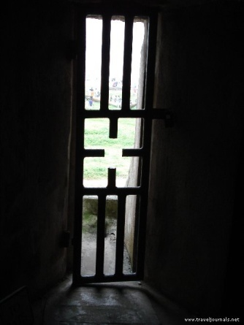
The “door of no return” at Elmina Castle. It leads from the dungeons of Elmina Castle in Ghana, West Africa to a harbor where slave ships docked. Elmina Castle was built on an island by the Dutch and African empires that controlled this area of West Africa in the 1700-1800s. Both the Dutch and West African empires accumulated great power and wealth as thousands of enslaved Africans passed through the Door of No Return onto slave ships that took them to the New World.

South Carolina
Along the coastal lands of South Carolina are rice fields, they are now abandoned; the land has been reclaimed by wild grass and a few river alligators. The Gullah, African Americans who were originally from the West Coast of Africa, still populate the barrier islands along the coast today. During the 1700’s enslaved people worked tirelessly under deadly conditions to grow a crop that was as profitable as gold. Over 40,000 acres of land was cleared and 780 miles of canals were dug by the beginning of the 1800s. Disease, heat-stroke, and injuries killed many who worked the rice fields, but the rice was so valuable that the demand for enslaved people grew. The fields had to be carved out of tidal swamp lands where huge cypress and gum trees grew. The swamps were full of alligators, snakes, and disease carrying mosquitoes and African slaves overcame it all to build the South Carolina rice plantations around Charleston and Georgetown. The existence and success of South Carolina’s rice plantations was due to the forced labor of enslaved people and the knowledge these Africans brought from their homeland.

Background: Old World Rice
Rice is a tall grass and we eat its seeds. Rice has traditionally thrived in warm, wet climates and people have depended on rice as a food source for thousands of years. Researchers have traced two origins of rice; oryza sativa from Asia and oryza glaberrima from Africa. Cultivation of rice in Africa began along the Niger, Sine-Saloum, and Casamance Rivers and archaeologists have uncovered evidence of rice cultivation 2,000 to 3,000 years ago in these West African regions. Modern West African countries that produce rice are Niger, Senegal, Ghana, Cote d’Ivorie, Mali, Sierra Leone, and Congo.
Fifteenth century Portuguese explorers reported three crops that were grown in abundance in West Africa; rice, millet, and sorghum. These crops created surpluses relied on by the Portuguese explorers and slave trading ships to feed the people on their voyages. Valentim Fernandes, a German travelling with Portuguese explorers from 1506-1510 recorded that the Gambian Mandinka traded in rice, millet, milk, and meat, he wrote: “They eat rice, milk, and millet. Their food is like that of the Wolof [of Senegal] except that they eat more rice and they have so much that they take it to sell and exchange.” (Carney) There are many written accounts from early explorers that document the agricultural practices of West African farmers, including production in different climates such as tidal floodplains, inland wetlands, rain-fed uplands, and mangrove swamps. The Portuguese introduced Asian rice varieties to Africa in the 16th century and many of the Africans sold into slavery understood the cultivation techniques of both Asian and African species of rice.
Rice in the New World
Unlike Africa and Asia, rice was not native to the Americas. Nor were the techniques used to grow rice, both the knowledge and the seed were introduced to the New World by explorers and African slaves that were brought here. Rice was first cultivated in the Caribbean and South America because the climate is warm and wet and these areas of the New World were first explored. Spanish explorers introduced rice into Mexico in the 1520’s and the Portuguese introduced rice into Brazil about the same time.
How rice arrived in South Carolina is debated, but one theory is rice was introduced in 1685 in Charleston by John Thurber, a sea captain who paid for the repair of his ship with a sack of “Gold Seede” rice from Madagascar. Madagascar is an island off the east coast of Africa. Whether this is a true story or not is still debated, but historians do know from cargo records that a bushel of rice was sent to the colony in 1672 on the supply ship William and Ralph. (West) The historical records of South Carolina shows how valuable rice became by 1691 because in this year the South Carolina Assembly passed an act that allowed the colonists to pay their taxes in rice. As rice grew more profitable the towns of Charleston and Georgetown in South Carolina grew into wealthy ports that imported slaves from West Africa and exported rice to European countries that paid a premium for the “Carolina Gold.” These ports were entrances for the West Africans coming into the colonies and slave trading firms flourished in these towns.

Slavery in the New World
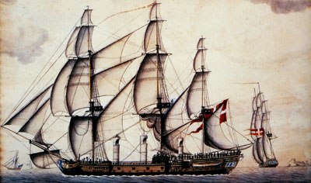
“The Fredensborg II heading for St. Croix with a cargo of slaves.” (Svalesen) Original in the Danish National Archives, Copenhagen.
Look at the ship and take note of the three cylindrical structures coming up from the deck. What are these funnels used for?

The institution of slavery was not new in the 1600-1700s. This system of labor exploitation has been used throughout history and continues to this day. In the New World, African slaves were first brought to replace enslaved Native Americans in the gold mines of Central America and to work on sugar plantations in the Caribbean. Although slavery was not new, the extent and impact of the transatlantic slave trade that developed in the 1600s was unparalleled. Slaves were brought by the millions, though the exact number is not truly known. They came to work the rice, sugar, indigo, coffee, tobacco, and cotton plantations of the British, Portuguese, and Spanish colonies.
Looking back to the 1700s
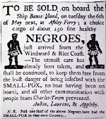
Library of Congress, Prints and Photographs Division, LC-USZ62-10293. This advertisement was in the South Carolina Gazette in 1760, placed by a merchant slave importer from Charleston. It is advertising the sale of Africans from the “Windward and Rice Coast,” and stresses their freedom from smallpox. Why does the advertisement note where the Africans are from?
It is early in the spring of 1760 and a ship carrying enslaved West Africans has made its way into Winyah Bay on its way to Georgetown, South Carolina. The ship left the slave port in Elmina—now in Ghana-- several months earlier. After the ship docks in Georgetown it is unloaded and the people are separated into groups of men and women, healthy and unhealthy. From these groups 39 people from a preferred area of West Africa are taken to South Carolina’s largest and wealthiest city of Charlestown and are sold by the slave trading firm of David & John Deas. They are bought by a South Carolina rice plantation owner who pays 100 to 200 English sterling pounds per person, in today’s money this is $12,000 to $24,000. These slaves were bought at a premium to work on a South Carolina rice plantation because they brought with them specific knowledge of rice production from West Africa. Their knowledge made them very valuable to the rice plantation owner who depended on their knowledge, skills, and strength to work on the plantation.
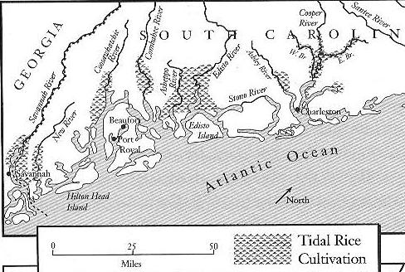
(Carney) p. 79 Tidal Rice Rivers, South Carolina
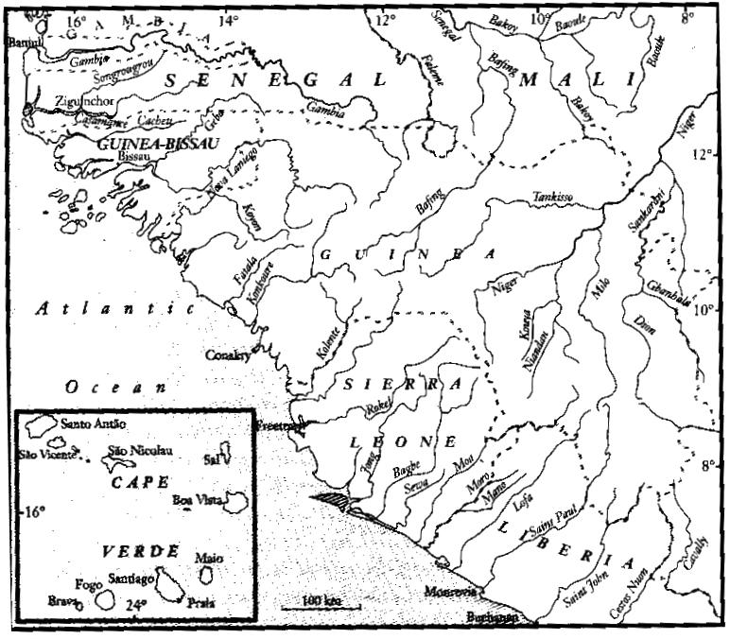
(Carney) p. 14 the West African Grain or Rice Coast
West African’s sold into slavery for rice cultivation were sent to rice plantations located around the South Carolina coastal river deltas. Once on the plantation, the work was daunting; they would clear an acre of swamp land into a smooth watery rice plain. The marshy flood plain was first measured into rectangular fields and marked into quadrants, each quadrant measured from 10 to 30 acres. After the surveying was complete the process of clearing the land would begin. First the trees are chopped down and burned. If the plantation owner allowed his oxen to work in the field at this early stage, the animals had to be fitted with a special boot or they would sink into the mud and not be able to get out. If oxen were not brought in the trees and tree roots would be worked free from the mud by enslaved Africans and Native Americans. After the trees were removed an embankment would be built around the entire flood plain and a canal dug on the other side of the embankment. Historical archeologists have found evidence from records that the embankments were six or more feet tall and 15 feet wide. When compared to building the Egyptian Pyramids, the amount of dirt moved along just the East Branch of the Cooper River was estimated to be three times the volume of the world’s largest pyramid-Cheops (Carney pg. 94). This tremendous amount of work was done all along the South Carolina and later, the Georgia coast line.

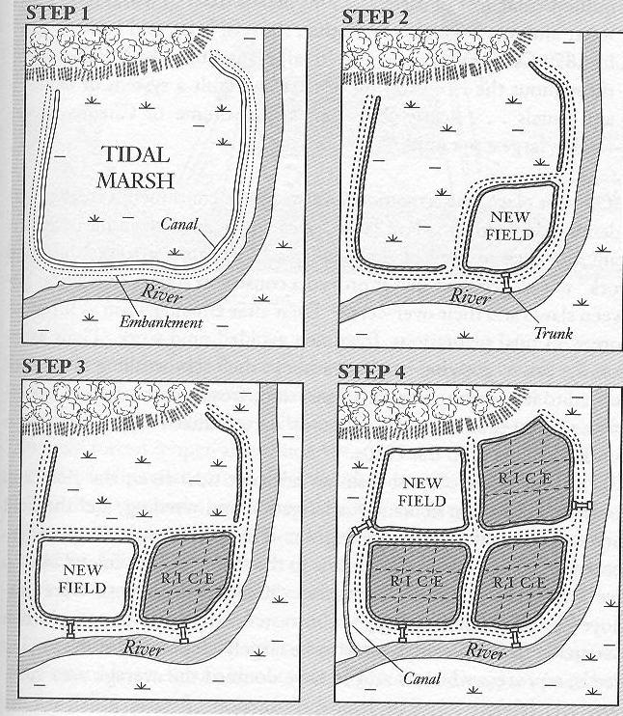
Step 1: trees are removed. An embankment is built around the acre and a canal is dug around the outside of the embankment. The changes to the land allow the swamp to be drained of water.
Step 2: a quadrant (one-quarter) of the field is again surrounded by an earthen dike and a “trunk” is inserted.
Steps 3 and 4: The process is repeated until the whole acre is planted with rice.
(Carney) p. 93 Tidal swamp conversion, South Carolina
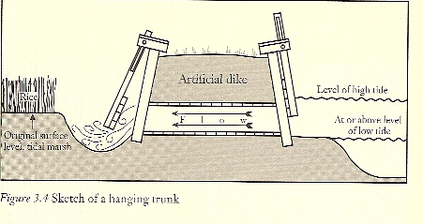
(Carney) A “hanging trunk” that controlled the tides flowing into the rice field.
In the early stages of clearing the Carolina swamps for rice production the mortality rate was very high for both African and Native American slaves. The mortality rate for Native Americans was even higher because they had no resistance to small pox or other European diseases. It became clear to European slave holders that reliance on Native American slaves for the manual labor of rice production would not work; this only increased the reliance on West Africans. In addition to the knowledge, skills, and endurance West Africans had to work the rice fields, the environment in South Carolina and West Africa was similar. There was a vast network of rivers controlled by the tides, the soil was rich, and the weather was wet and warm, the coast of South Carolina and the coast of West Africa receive between 48-52 inches of rain a year. Many of the West African slaves knew how to rice farm using the network of rivers and by using a rain fed irrigation system because they used the same techniques in their homeland.
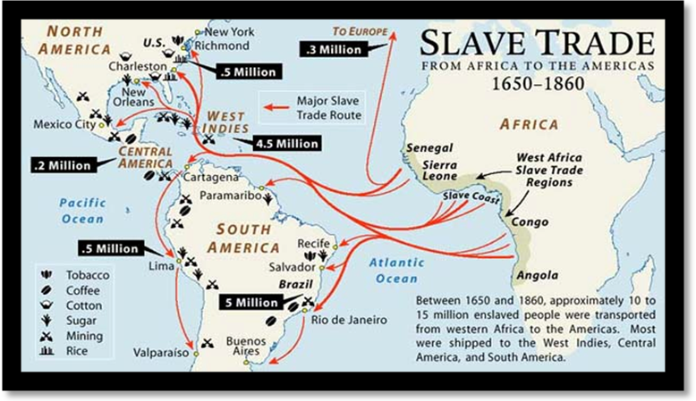
http://www.slaveryinamerica.org/geography/slave_trade.htm
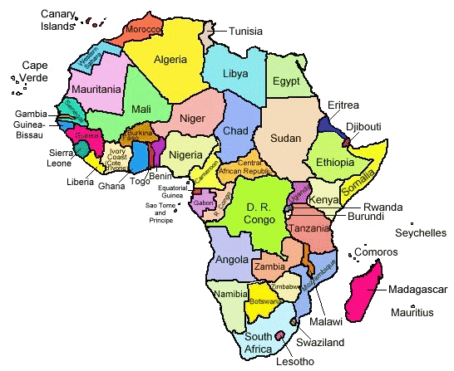

STUDENT QUESTIONS FOR SLAVERY ON SOUTH CAROLINA RICE PLANTATIONS
- Name three countries in West Africa traditionally involved in growing rice:

- Compare these countries to the slave trading map. Is there a large proportion of Africans from these areas being enslaved? __________
- How did food surpluses in Africa contribute to the transatlantic slave trade? ________________________________________________________________________________________________________________________________________________________________________________________________________________________________________________________________________________________________________________________
- Discuss the reasons plantations owners in South Carolina would want people from these regions in West Africa ______________________________________________________________________________________________________________________________________________________________________________________________________________________________________________________________________________________________________________________________________________________________________________________________________
- Why were people from West Africa preferred to work on rice plantations over other people? ________________________________________________________________________________________________________________________________________________________________________________________________________________________________________________________________________________________________________________________
- What rice variety originates from Asia? ______________________________________________
- What rice variety originates from Africa?_____________________________________________
- How many acres of land were converted into rice fields in South Carolina? ____________________________________________________________________________________________________________________________________________________________
- Describe how the swamp land was converted into rice fields. ______________________________________________________________________________________________________________________________________________________________________________________________________________________________________________________________________________________________________________________________________________________________________________________________________
Use the maps of West Africa and South Carolina to compare the two and then answer the following questions.
- What similarities in geography can you find between South Carolina and West Africa? __________________________________________________________________________________________________________________________________________________________________________________________________________________________________________
- How did geography and climate played an important role in the development of the rice plantations in South Carolina? Why? ____________________________________________________________________________________________________________________________________________________________
Looking at the numbers
The Carolina Gold rice variety that was brought to South Carolina was highly prized by grocers in England and exported by the ton. Rice even assumed the importance of money, being accepted as payment for taxes and for over a century this single agricultural crop sustained the economy of Georgetown and Charleston. As rice production grew, so did the enslaved African population and by 1765 there were over 90,000 slaves in South Carolina and approximately 40,000 tons of rice was exported to Europe.
Answer the following questions using Tables 1 and 2.
- How many tons of rice was exported in 1726? ______ What was the slave population in South Carolina in 1724? __________. Compare these two numbers to the tons of rice exported in 1700 ______ and the number of slaves in 1708 ________.
Use the graph below to compare rice exports (Table 1) and the slave population (Table 2). How are they related? Explain the correlation between the two data sets? ______________________________________________________________________________________________________________________________________________________________________________________________________________________________________________________
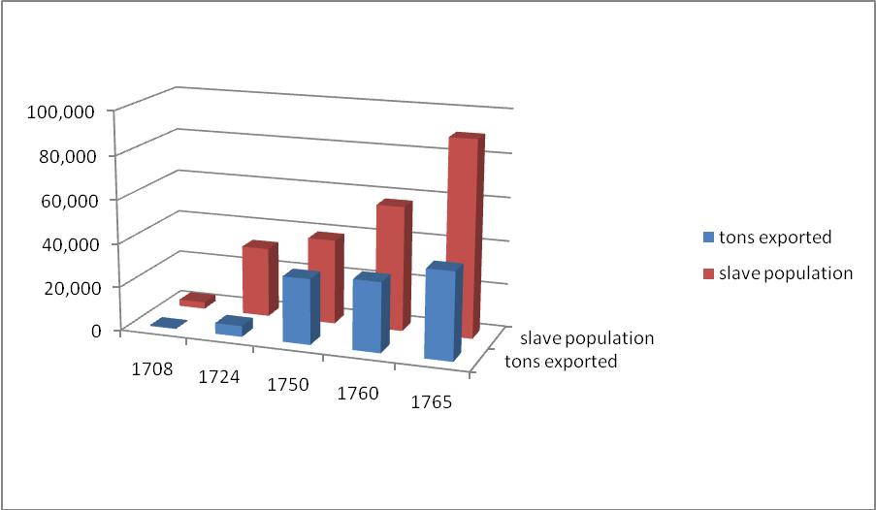
Figure 1: Slave population (Table 1) and rice exports from South Carolina (Table 2) by year. Mathematically a correlation exists when two variables are affected by one another and a linear relationship is formed. In a positive correlation the two variables would increase together. In a negative correlation as one variable increased, the other would decrease. What type of correlation exists between the South Carolina slave population and the amount of rice exported?

Table 1: South Carolina Colonial Rice Exports
1698 | 1700 | 1726 | 1730 | 1740 | 1763 | 1764 | 1770
5 tons | 330 tons | 5,000 tons | 10,000 tons | 25,000 tons | 35,000 tons | 40,000 tons | 42,000 tons

Table 2: Slave Population of South Carolina 1708-1860
Year | Number of slaves | Total population | Percentage Of Population Enslaved
1708 | 3,000 | 9,500 | 31.5 percent
1724 | 32,000 | 46,000 | 69.5 percent
1750 | 39,000 | 64,000 | 60.9 percent
1760 | 57,253 | 76,000 | 75 percent
1765 | 90,000 | 130,000 | 69.2 percent
1790 | 107,094 | 249,073 | 42 percent
1800 | 149,338 | 345,591 | 42.1 percent
1810 | 196,365 | 415,115 | 46.1 percent
1820 | 258,475 | 502,741 | 50.2 percent
1830 | 315,401 | 581,185 | 53.9 percent
1840 | 327,038 | 594,398 | 53.9 percent
1850 | 384,984 | 668,507 | 57.6 percent
1860 | 402,406 | 703,708 | 57.2 percent
Table 3: Rice Prices, 1772-1809*
Time Period | Rice Price (cent/lb)
1722-29 | 1.40
1730-39 | 1.64
1740-49 | 1.18
1750-59 | 1.56
1760-69 | 1.58
1770-79 | 1.87
1780-89 | 3.15
1790-99 | 2.73
1800-09 | 3.81

Table sources: (Cole) (p. 152) as cited by (Mancall, Rosenbloom and Weiss)

Sources:
Carney, Judith A. Black Rice. Cambridge : Harvard University Press, 2001.
Cole, Arthur Harrison. Wholesale Commodity Prices in the United States, 1700-1861. Cambridge : Harvard University Press, 1938.
Mancall, Peter, Joshua Rosenbloom and Thomas Weiss. "Slave Prices and the Economy of the Lower South, 1722-1809." January 2000. <http://www.eh.net/Clio/Conferences/ASSA/Jan_00/rosenbloom.shtml>.
Svalesen, Leif. The Slave Ship Fredensborg. Kingston, Jamaica: Ian Randle, 2000.
West, Jean M. "Rice and Slavery: A Fatal Gold Seede." slaveryinamerica.org. 15 March 2009 http://www.slaveryinamerica.org/history/hs_es_rice.htm.
UNESCO_Slave trade map_ 2006:
http://docsouth.unc.edu/neh/neilson/menu.html The project is titled “Documenting the American South” and is a collection of primary documents kept electronically by the University of North Carolina.
http://hitchcock.itc.virginia.edu/slavery/ This is a visual history of the transatlantic slave trade.
Confronting the Legacy of the African Slave Trade. PBS on line collection of documents concerning the slave trading empires of West Africa. http://www.pbs.org/wonders/fr_e3.htm

Chicora Historical Society. http://www.sciway.net/hist/chicora/slavery 18-2.html
http://www.sciway.net/hist/chicora/slavery18-2.html

