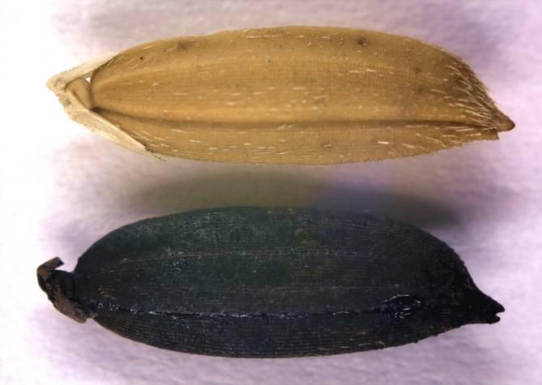
Can you help determine if this rice is Carolina Gold?
Carolina Gold Rice
Archaeological Sample

The black seeds were found in an archaeological site with other artifacts from the Hurricane of 1752. A historian from the Charleston Museum in South Carolina recently brought the seeds and a question to scientists at the USDA Rice Research program in Stuttgart, Arkansas. Could the seed be Carolina Gold Rice from 1752?
Black Rice?
Why is the archaeo-logical sample black? The archaeological site was a naval supplies storage area. The supplies included tar and pitch, which perfectly preserved all of the items there—including the mystery rice! But the rice turned black in the preservation process!

Why was Carolina Gold rice important in 1752?

This question is intended to review and link to the social studies lessons.

In 1752, rice was a major export crop from the colony of South Carolina. Nearly seventy percent of the colony’s population were slaves—many of whom were engaged in rice production. Rice was highly valuable—as good as currency, in some cases!

How can you figure out whether the archaeological sample is Carolina Gold rice?

This would make an excellent discussion question. Students need to come up with some ways to compare the two types of rice.

One obvious approach is to compare the samples physically—to look at their phenotypes.

Hopefully some astute students will think of comparing what’s inside the seeds. This could mean phenotype (measuring starch content, protein levels, color, cooking time) or it could mean genotype. Evaluating genotypes allows a deep look at the history of each type of rice and explores the underlying basis for phenotype.

Part I: Physical Data
Carolina Gold Rice
Archaeological Sample

The seeds in the photo look alike. But that isn’t good enough for science. What kind of data can you collect to see if the seeds are physically similar?
Data Notes
Data comes in all shapes and sizes.
- Qualitative data describes in words.
- Quantitative data describes in numbers.

Choose three of those characteristics and fill in the data table.
Data Notes:
Data comes in all shapes and sizes.
- Qualitative data describes with words.
- Quantitative data describes with numbers.
Other characteristics could include: seed width, seed length, seed weight, seed volume (water displacement), color, texture, shape…
 | Characteristic 1 ten grain weight_  qualitative/quantitative | Characteristic 2  ten grain length_  Qualitative/quantitative | Characteristic 3 _grain color_____ qualitative/quantitative
Carolina Gold 1
Carolina Gold 2
Carolina Gold 3
Carolina Gold 4
AVERAGE
Archaeological Sample 1
Archaeological Sample 2
Archaeological Sample 3
Archaeological Sample 4
AVERAGE
Is the data in your table a genotype or a phenotype? Why?
Data Notes:
Measuring one grain just isn’t enough! How do you know that one grain is a good representative? Instead, measure several and average.

Or even better, measure several sets of ten grains. 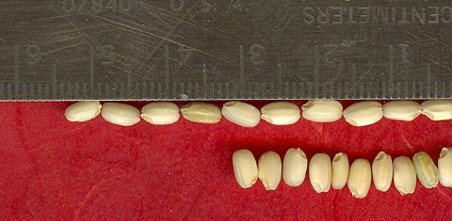
Geno or Pheno?
A phenotype is the physical description of an individual—its color, taste, smell and shape. A genotype describes the genes behind those characteristics.

The data in the table describes a phenotype—physical characteristics of the rice samples.

Is the archaeological sample Carolina Gold Rice? Why or why not? (Use data to support your hypothesis.)

The data is not clear enough to be conclusive. The two varieties are very simliiar, physically. However, there are also some differences. Most important is that students use their data to make a logical argument.

Discussion: what other kind of data would help you decide?
This question is intended to help students think beyond the physical. Answers might include genetic data, or internal analysis like protein or starch content.

Part IIa: Genetic Data

Would it be easier to know if the rice was the same if you had a way to look inside the seed and see its history? Scientistis use genetic fingerprints to look at DNA differences—differences in genotype. DNA differences reflect an individual’s ancestors and history.
Data Notes
What is a genetic fingerprint? It is a stretch of DNA—called a marker—used for identification.

What is DNA?
DNA, deoxyribonucleic acid, is the hereditary material. It is made up of a sugar-phosphate backbone with four bases (A, T, G and C). The bases pair together A with T and G with C to create a double helix structure. DNA encodes all the proteins that are made in an organism.
Where is it found?
It is grouped into functional units called genes, wound tight into chromosomes and packed into the nucleus of the cell.

To make genetic fingerprints, a scientist prepares DNA from the samples and then runs it through a gel—a clear, jiggly solid like Jello. This creates a pattern of bands, because bigger pieces of DNA move slowly and smaller pieces move faster. Each marker sits at a separate place in the DNA.

Here is a gel comparing DNA from a mouse, a rabbit and an elephant at three markers.
Data Notes
The white bands on this gel are DNA. When electricity is applied to the gel, the DNA moves from top to bottom. Smaller pieces of DNA can move farther (think of rocks in a stream).
The ladder on the side is DNA of known sizes. Size is measured in base pairs (bp). Compare a band to the ladder to see its size.
200
175
150
125
100
75
Size (bp)
Size Standard
Marker 1
Mouse
Rabbit
Elephant
Marker 2
Mouse
Rabbit
Elephant
Marker 3
Mouse
Rabbit
Elephant
For which marker is the DNA of all three animals the same?
Marker 2

Mouse’s DNA is unique at which marker? How big is the band for the mouse?
Marker 3. About 180 base pairs.

At marker 1, is elephant’s band larger or smaller than mouse’s?
Smaller. Mouse’s is about 165 base pairs. Elephant’s is about 150 base pairs.

Carolina Gold Rice
Archaeological Sample
Part IIb: Genetic Data for Carolina Gold Rice—Predictions

Now you can compare the DNA of Carolina Gold rice to your archaeological sample to see if they are the same.

What do you predict the gel would look like if the archaeological sample is Carolina Gold rice? Draw the bands.
Marker 2
Carolina
Gold
Archaeolo-gical Sample
Marker 1
Carolina
Gold
Archaeolo-gical Sample
200
175
150
125
100
75
Size (bp)
Size Standard
Marker 3
Carolina
Gold
Archaeolo-gical Sample
Marker 4
Carolina
Gold
Archaeolo-gical Sample
If the archaelogical sample is Carolina Gold, the predicted bands would match the Carolina Gold bands.

The bands would match because of a common genetic heritage reflecting shared ancestry.

Part IIc: Genetic Data for Carolina Gold Rice

Here is the gel comparing the archaeological sample to Carolina Gold rice.
Marker 2
Carolina
Gold
Archaeolo-gical Sample
Marker 1
Carolina
Gold
Archaeolo-gical Sample
200
175
150
125
100
75
Size (bp)
Size Standard
Marker 3
Carolina
Gold
Archaeolo-gical Sample
Marker 4
Carolina
Gold
Archaeolo-gical Sample
Data Notes
The white bands on this gel are DNA. When electricity is applied to the gel, the DNA moves from top to bottom. Smaller pieces of DNA can move farther (think of rocks in a stream).
The ladder on the side is DNA of known sizes. Size is measured in base pairs (bp). Compare a band to the ladder to see its size.

Circle the Carolina Gold bands on the gel. Are the bands for the archaeological sample the same size? Fill in the band sizes in the table.
 | Band size (bp)  Carolina Gold | Band size (bp)  Archaeological Sample
Marker 1 | 112 | 105
Marker 2 | 155 | 162
Marker 3 | 174 | 181
Marker 4 | 153 | 153
Markers 1,2, and 3 show different sized bands for Carolina Gold and the archaeological sample. The bands for Marker 4 are the same size.

Is the archaeological sample Carolina Gold Rice? Why or why not? (Use data to support your hypothesis.)
Carolina Gold has different bands than the archaeological sample for Markers 1, 2 and 3. Therefore they are not the same type of rice.

(Note: If you were looking at only Marker 4, you might conclude that the samples are the same. If you were looking at only Marker 1, you would likely conclude they were different. This is why scientists look at many markers for an analysis like this.)

Do these data represent genotypes or a phenotypes? Why?

These data represent the genes inside the plant—the genotype.

Part III: Where does Carolina Gold come from?
To determine where Carolina Gold rice comes from, we can examine rice varieties from all over the world using Marker 1 and Marker 3 where Carolina Gold has a unique band.

What band do you predict rice related to Carolina Gold would have for Marker 1? For Marker 3? Why?
If the rice is related, it would likely have the same unique bands as Carolina Gold for markers 1 and 3. They’re similar because they’re related—or in gentic terms, they have shared ancestry.

Note that Marker 1 and Marker 3 have been selected from an initial study of many markers (the original study had about 100) because they are UNIQUE in Carolina Gold. There will be many other markers, at which Carolina Gold is not unique (like Marker 4 above)—these won’t help you find the relatives of Carolina Gold.

Find and circle the varieties that have the same alleles as Carolina Gold
1. Carolina
Gold
2. Champa Zoodrus
3. Bakoram
4. Yaka-dawee
5. JST58
6. Che Shau Nan Bir
Marker 3
7. Angkrang
8. Yana-yanan
9.
Vary Lava 9
10. Karang Serang
11. Shuho
12. Laat
13. Blue Nile
14. Pata de Gallinazo
15. Shala
16. Nacaome
180
160
150
140
130
120
110
Size (bp)
Size Standard
170
1. Carolina
Gold
2. Champa Zoodrus
3. Bakoram
4. Yaka-dawee
5. JST58
6. Che Shau Nan Bir
Marker 1
7. Angkrang
8. Yana-yanan
9.
Vary Lava 9
10. Karang Serang
11. Shuho
12. Laat
13. Blue Nile
14. Pata de Gallinazo
15. Shala
16. Nacaome
130
120
115
110
105
100
95
Size (bp)
Size Standard
125
Note that JST58 has two bands—in addition to the Carolina Gold band at ~153bp, it also has a second band at 120 bp. JST58 is heterozygous, meaning it has two alleles or bands. Rice is usually homozygous, with only one band because it is a self-pollinating plant. When the pollen of a self-pollinating plant fertilizes the ovule inside the closed flower, over generations, the variety tends to become homozygous. However, some heterozygosity persists. The ~153 bp allele shows common ancestry with Carolina Gold. Obviously though, JST58 is not identical.

Where do varieties simliar to Carolina Gold Rice come from? (Find their numbers on the map and put their locations into the data table.)
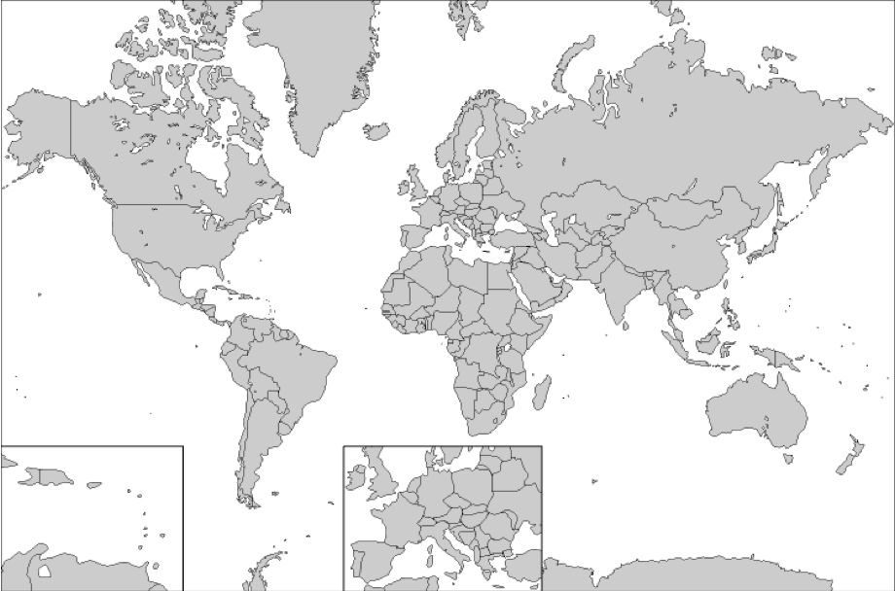
1

2

3

4

5

6

7

8

9

10

11

12

13

14

15
\\

16

http://www.educypedia.be/education/Images/worldmap.png

Variety | Geographic origin
1. Carolina Gold | United States
3. Bankoram | Ghana
5. JST58 | Morocco
** Note that for marker 3, varieties 12, 13 and 14 have bands that are not the same as Carolina Gold—though they are very close in size, they do not reflect shared ancestry.
Where do you hypothesize that Carolina Gold Rice comes from? Use data to support your answer.

Carolina Gold is very similar to rice from Africa (Morocco and Ghana). Both Bankoram (variety 3) and JST58 (variety 5) have the same alleles as Carolina Gold for both markers 1 and 4. (Indeed, Bankoram shares 46 of 47 tested markers with Carolina Gold!)

Is this origin consistent what you know of the history of Carolina Gold rice? Explain.

This question is intended to tie back to the social studies curriculum.

Carolina Gold is thought to have come to the Colonies from Africa—probably Madagascar (where variety 9 is from as well). The people who had the knowledge to grow Carolina Gold—the West African slaves—came from Ghana, so it is not at all surprising that a very similar vareity might be found there. Perhaps the slaves brought seed as well as knowledge!
Teacher notes
Carolina Gold

Prior Knowledge required:
- Social studies intro to Carolina Gold. Through this, students will know that Carolina Gold was a major export crop from the Colonies between1750 and 1800.
- DNA and Genetics. Students should know that DNA carries hereditary information and that it is found in the nucleus of cells.
- World geography. Students will have to identify countries or regions that Carolina Gold’s relatives come from using an unlabeled world map.

Additional activity resources:
- Data table for Part I: Due to time or resource constraints, you may prefer to NOT have your students measure their own seeds. You can substitute the data table with measurements found at the end of the exercise.
- Labeled world map: Students may need a labeled world map in order to identify Carolina Gold’s relatives around the world. Maps are available online at: http://www.mapsofworld.com/world-political-map.htm. There is also one at the end of this document.
- Molecular Biology. This activity glosses over the molecular biology that underlies gel electrophoresis. To do these activities, a scientist would 1) extract DNA from the rice varieties, 2) do PCR to make many copies of regions of interest, and 3) set up and run gel electrophoresis to separate the DNA into the band patterns shown in the activity.
  - DNA extraction. To extract DNA, you must break open the cells and the nucleus (and the cell walls in a plant). Once the DNA is free and in solution, you must “clean” it by removing all the other cell contents. Finally you must concentrate it so you have a solution of pure DNA. BioRad makes a kit where students can extract their own DNA: http://www.bio-rad.com/cmc_upload/Literature/54133/4110034B.pdf. The University of Utah has a good “virtual lab” where students can see the process. http://learn.genetics.utah.edu/content/labs/extraction/
  - PCR or polymerase chain reaction. This is a way to make many copies of a targeted stretch of DNA. The lab technique capitalizes on the natural process of copying DNA every time a cell divides. http://learn.genetics.utah.edu/content/labs/pcr/ has a “virtual lab” where students can explore the process. Kary Mullis (who won a Nobel prize for “discovering” the process) has a good video of how it works: http://www.karymullis.com/pcr.shtml.
  - Gel electrophoresis: The University of Utah has an excellent “virtual lab” where students can see how gels work, as well as virtually make, load and run a gel. http://learn.genetics.utah.edu/content/labs/gel/

Data Table for Part I
 | Characteristic 1 ten grain weight_  qualitative/quantitative | Characteristic 2  ten grain length_  Qualitative/quantitative | Characteristic 3 _grain color_____ qualitative/quantitative
Carolina Gold 1 | 115 mg | 9.4 cm | gold
Carolina Gold 2 | 108 mg | 8.9 cm | gold
Carolina Gold 3 | 113 mg | 9.6 cm | gold
Carolina Gold 4 | 112 mg | 9.5 cm | gold
AVERAGE
Archaeological Sample 1 | 100 mg | 9.3 cm | black
Archaeological Sample 2 | 102 mg | 9.7 cm | black
Archaeological Sample 3 | 98 mg | 9.1 cm | black
Archaeological Sample 4 | 106 mg | 9.5 cm | black
AVERAGE

