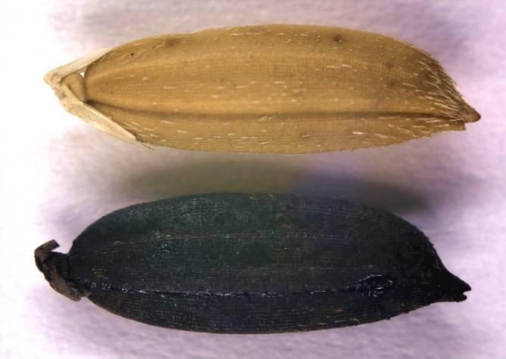
Can you help determine if this rice is Carolina Gold?
Carolina Gold Rice
Archaeological Sample

The black seeds were found in an archaeological site with other artifacts from the Hurricane of 1752. A historian from the Charleston Museum in South Carolina recently brought the seeds and a question to scientists at the USDA Rice Research program in Stuttgart, Arkansas. Could the seed be Carolina Gold Rice from 1752?

Why was Carolina Gold rice important in 1752?
Black Rice?
Why is the archaeo-logical sample black? The archaeological site was a naval supplies storage area. The supplies included tar and pitch, which perfectly preserved all of the items there—including the mystery rice! But the rice turned black in the preservation process!

How can you figure out whether the archaeological sample is Carolina Gold rice?

Part I: Physical Data
Carolina Gold Rice
Archaeological Sample

The seeds in the photo look alike. But that isn’t good enough for science. What kind of data can you collect to see if the seeds are physically similar?
Data Notes
Data comes in all shapes and sizes.
- Qualitative data describes in words.
- Quantitative data describes in numbers.

Choose three rice characteristics and fill in the data table.
Data Notes:
Data comes in all shapes and sizes.
- Qualitative data describes with words.
- Quantitative data describes with numbers.
 | Characteristic 1 __________________  qualitative or quantitative | Characteristic 2 _________________  qualitative or quantitative | Characteristic 3 __________________ qualitative or quantitative
Carolina Gold 1
Carolina Gold 2
Carolina Gold 3
Carolina Gold 4
AVERAGE
Archaeological Sample 1
Archaeological Sample 2
Archaeological Sample 3
Archaeological Sample 4
AVERAGE
Data Notes:
Measuring one grain just isn’t enough! How do you know that one grain is a good representative? Instead, measure several and average.

Or even better, measure several sets of ten grains. 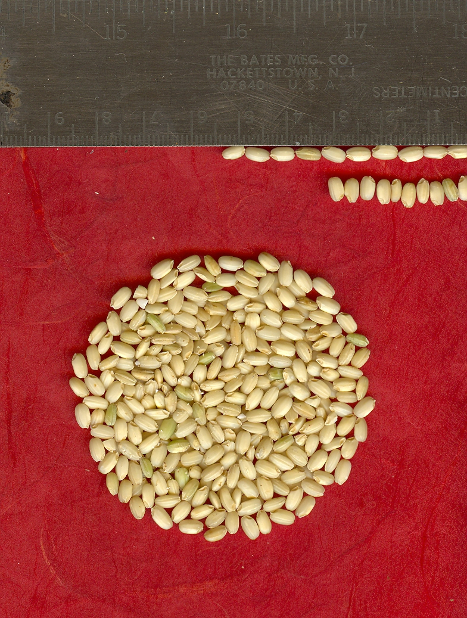
Geno or Pheno?
A phenotype is the physical description of an individual—its color, taste, smell and shape. A genotype describes the genes behind those characteristics.
Is the data in your table a genotype or a phenotype? Why?

Is the archaeological sample Carolina Gold Rice? Why or why not? (Use data to support your hypothesis.)

Discussion: what other kind of data would help you decide?

Part IIa: Genetic Data

Would it be easier to know if the rice was the same if you had a way to look inside the seed and see its history? Scientistis use genetic fingerprints to look at DNA differences—differences in genotype. DNA differences reflect an individual’s ancestors and history.
Data Notes
What is a genetic fingerprint? It is a stretch of DNA—called a marker—used for identification.

What is DNA?

Where is it found?

To make genetic fingerprints, a scientist prepares DNA from the samples and then runs it through a gel—a clear, jiggly solid like Jello. This creates a pattern of bands, because bigger pieces of DNA move slowly and smaller pieces move faster. Each marker sits at a separate place in the DNA.

Here is a gel comparing DNA from a mouse, a rabbit and an elephant at three markers.
Data Notes
The white bands on this gel are DNA. When electricity is applied to the gel, the DNA moves from top to bottom. Smaller pieces of DNA can move farther (think of rocks in a stream).
The ladder on the side is DNA of known sizes. Size is measured in base pairs (bp). Compare a band to the ladder to see its size.
200
175
150
125
100
75
Size (bp)
Size Standard
Marker 1
Mouse
Rabbit
Elephant
Marker 2
Mouse
Rabbit
Elephant
Marker 3
Mouse
Rabbit
Elephant
For which marker is the DNA of all three animals the same?

Mouse’s DNA is unique at which marker? How big is the band for the mouse?

At marker 1, is elephant’s band larger or smaller than mouse’s?

Part IIb: Genetic Data for Carolina Gold Rice—Predictions
Carolina Gold Rice
Archaeological Sample

Now you can compare the DNA of Carolina Gold rice to your archaeological sample to see if they are the same.

What do you predict the gel would look like if the archaeological sample is Carolina Gold rice? Draw the bands.
Marker 2
Carolina
Gold
Archaeolo-gical Sample
Marker 1
Carolina
Gold
Archaeolo-gical Sample
200
175
150
125
100
75
Size (bp)
Size Standard
Marker 3
Carolina
Gold
Archaeolo-gical Sample
Marker 4
Carolina
Gold
Archaeolo-gical Sample

Part IIc: Genetic Data for Carolina Gold Rice

Here is the gel comparing the archaeological sample to Carolina Gold rice.
Marker 2
Carolina
Gold
Archaeolo-gical Sample
Marker 1
Carolina
Gold
Archaeolo-gical Sample
200
175
150
125
100
75
Size (bp)
Size Standard
Marker 3
Carolina
Gold
Archaeolo-gical Sample
Marker 4
Carolina
Gold
Archaeolo-gical Sample
Data Notes
The white bands on this gel are DNA. When electricity is applied to the gel, the DNA moves from top to bottom. Smaller pieces of DNA can move farther (think of rocks in a stream).
The ladder on the side is DNA of known sizes. Size is measured in base pairs (bp). Compare a band to the ladder to see its size.
Circle the Carolina Gold bands on the gel. Are the bands for the archaeological sample the same size? Fill in the band sizes in the table.
 | Band size (bp)  Carolina Gold | Band size (bp)  Archaeological Sample
Marker 1 | 112 | 105
Marker 2 | 155 | 162
Marker 3 | 174 | 181
Marker 4 | 153 | 153

Is the archaeological sample Carolina Gold Rice? Why or why not? (Use data to support your hypothesis.)

Do these data represent genotypes or a phenotypes? Why?

Part III: Where does Carolina Gold come from?
To determine where Carolina Gold rice comes from, we can examine rice varieties from all over the world using Marker 1 and Marker 3.

What band do you predict rice related to Carolina Gold would have for Marker 1? For Marker 3? Why?

Circle the varieties that have the same alleles as Carolina Gold
1. Carolina
Gold
2. Champa Zoodrus
3. Bakoram
4. Yaka-dawee
5. JST58
6. Che Shau Nan Bir
Marker 1
7. Angkrang
8. Yana-yanan
9.
Vary Lava 9
10. Karang Serang
11. Shuho
12. Laat
13. Blue Nile
14. Pata de Gallinazo
15. Shala
16. Nacaome
130
120
115
110
105
100
95
Size (bp)
Size Standard
125
1. Carolina
Gold
2. Champa Zoodrus
3. Bakoram
4. Yaka-dawee
5. JST58
6. Che Shau Nan Bir
Marker 3
7. Angkrang
8. Yana-yanan
9.
Vary Lava 9
10. Karang Serang
11. Shuho
12. Laat
13. Blue Nile
14. Pata de Gallinazo
15. Shala
16. Nacaome
180
160
150
140
130
120
110
Size (bp)
Size Standard
170

Where do varieties simliar to Carolina Gold Rice come from? (Find their numbers on the map and put their locations into the data table.)
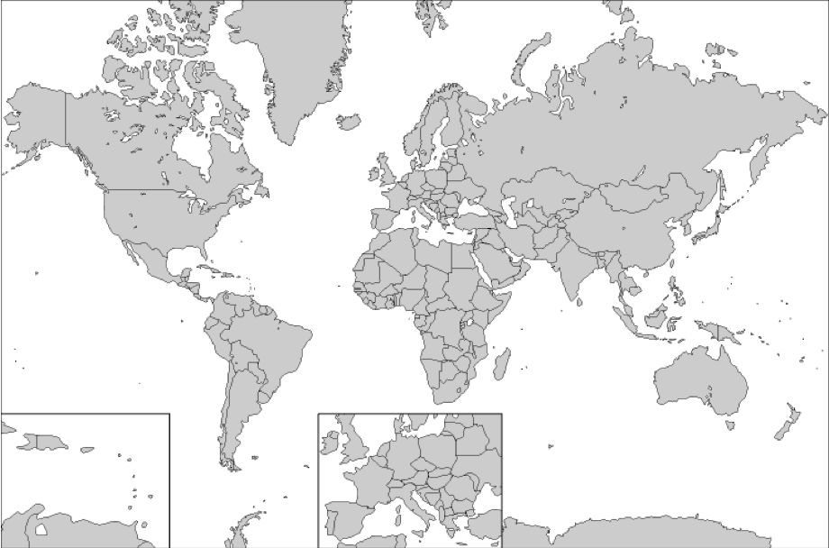
1

2

3

4

5

6

7

8

9

10

11

12

13

14

15
\\

16

http://www.educypedia.be/education/Images/worldmap.png

Variety | Geographic origin
1. Carolina Gold | United States
3. Bankoram | Ghana
5. JST58 | Morocco

Where do you hypothesize that Carolina Gold Rice comes from? Use data to support your answer.

Is this origin consistent what you know of the history of Carolina Gold rice? Explain.

