Part I: Where does rice come from?

The rice you eat comes from a plant. In order to make even one grain of rice, the plant must have some essential parts.

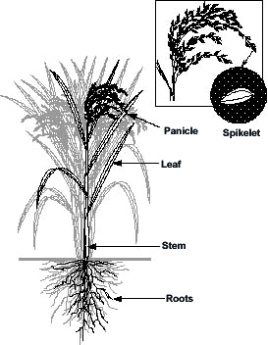
First, the plant needs roots. The roots go down into the soil. They anchor the plant to keep it from moving around. Roots are also the way that the plant acquires water and nutrients from the soil. Even a rice plant that can grow in standing water, only takes water in through its roots.
Grain of Rice
Tiller

The plant makes leaves to capture the energy of the sun. Leaves are full of chlorphyll, a green pigment, that converts sunlight into sugars through a process called photosynthesis. The leaves of a rice plant are long and thin—like blades of grass. This is not surprising, since rice is a grass, just like the plants of a lawn.

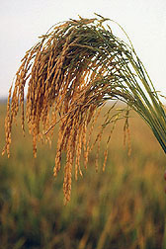
The plant has stiff, strong stems that support the leaves and grain. A rice plant has many stems, because the plant produces many tillers. Each tiller has its own roots, stem and leaves. Some tillers will make grain and others will not.

The plant takes sugars that are made in the leaves and moves them to the grain. In the panicle—the head of grain—the sugars are converted into starch and stored. Each grain of rice is really a seed, where the plant stores enough energy and nutrients to start the next generation. When we harvest grains of rice, we’re harvesting starch that the plant harvested from the sun.

USDA-ARS

Where does rice come from?

- Use the space below to draw a rice plant.

- Label a root, a stem, a leaf, a panicle, a grain, and a tiller.

- Why does a plant need each of these?
  - Roots__Roots anchor the plant and are how it obtains water and nutrients from the soil__________

  - Stems __ Stems support the grain and the leaves.____________________________________

  - Leaves __ Leaves capture the energy of the sun and via photosynthesis, convert it into sugars.______

  - Seeds (grain) __ The plant stores energy and nutrients in the seed to start the next generation._____

  - Tiller ___ The tiller is the plant’s way of making a maximum number of seeds when environmental conditions are good. A stem would collapse if a plant kept adding grain to one stem. So instead, it makes a new stem to hold more grain. The plant that produces the most offspring when conditions are good will pass on the most genes—natural selection at work!____________________

Part II: Where does rice come from?—What do we eat?

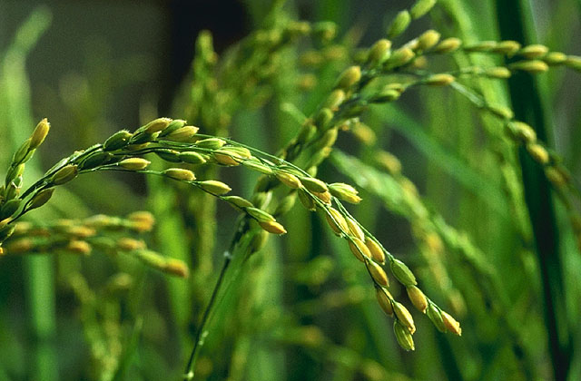
Eating the Future:
When we eat rice, we are eating the seed of the rice plant. Rice seeds, like all seeds, contain a tiny, baby plant called an embryo. The seed is like a lifeboat. The plant loads the boat with the baby plant, and all the food it will need until it can start making its own. The plant wraps the seed in a coat—a covering to protect it from sun, wind and insects that might eat it. Then the plant throws the seed overboard.
USDA-ARS
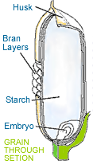
Starchy endosperm
The rice seed’s coat has several layers of tough tissue. These layers protect the rice seed from insects that might want to eat it—they like the starch as much as we do!

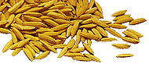
The outer-most layer is called the husk. It is a tough, rough layer that we can not digest. The husks are hard to remove from the rice seed. Many people pound harvested rice with sticks to remove these husks. A mill can also remove them. A 100 kg harvest of rice from the field will give 20 kg of rice husks. They are often used as a fuel source for milling machinery, or are dug into the ground as fertilizer.
http://www.producersrice.com/rice/types.html

What is the difference between brown rice and white rice?
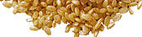
Brown rice has a bran layer on it. The bran layer is rich in Vitamin B and other vitamins. It’s the bran that makes brown rice so nutritious.

The bran layer can also be removed by milling, polishing or pounding. A 100 kg harvest of rice produces about 10 kg of rice bran. If it is separated from the rice, the bran is fed to animals or used to make nutritional supplements.

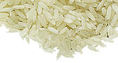
White rice has had all of the protective layers brushed, pounded or polished off. It contains only the starchy endosperm of the rice seed. The endosperm is where the seed stores energy to nourish the baby plant. The energy is starch. The starch provides energy to us too!

Neither white nor brown rice contains the embryo, or baby plant, any more. It is removed with the husk. Therefore if you plant any of the rice you can eat, it won’t grow.

Part V: Where does rice come from?

- Use the space below to draw a rice seed.

- Label the husk, the bran, the starchy endosperm and the embryo.

- Why does a plant need each of these?
  - Husk__The husk is like a coat the seed is wearing. It protects it from the sun and the wind—keeping it from drying out and dying. It also protects it from insects that want to eat the seed’s starch!__

  - Bran __ The bran is another protective layer. It is very rich in vitamins and nutrients.____________________________________

  - Starchy endosperm __ The endosperm is the starchy reserve that the baby plant (embryo) uses until it can reach the light and begin photosynthesizing. Remember that seeds start in the dark and can’t produce their own food until they have leaves..______

  - Embryo __ The embryo is the baby plant—look at the picture, it comes complete with already-formed leaves!.____

Teacher Notes. Anatomy of Rice

Overview and concepts

Overview
This activity allows students to identify the plant anatomy of where rice comes from.

Concepts covered
Anatomy of a rice plant

Prior knowledge required
Students should have familiarity with the following:
- Plants produce seeds. Rice grain is a seed.

Activity notes

Time frame
- Activity: One half day for plant anatomy.

Materials
- Activity handouts.

